Trigonometric identities:
sin (A±B) = sin(A)cos(B) ± cos(A)sin(B)
cos (A±B) = cos(A)cos(B) ∓ sin(A)sin(B)
tan (A±B) = $\frac{\tan\left(A\right)±tan⁡(B)}{1∓\tan\left(A\right)tan⁡(B)}$
It’s a relation and not a function because it isn’t one-to-one (for most values of $x$ there is more than one value of $y$).
It’s a function and not a relation because it is a one-to-one (for most values of $x$ there is more than one value of $y$).

Line A and Line B in the x-y plane intersect at 90° at the origin. Line A has a slope of $\frac{1}{3}$. Point (2, –6) is the midpoint of line segment CD which is parallel to Line A. Given that the x-value of C is –1, find the coordinates of point D.
2 = $\frac{-1+x}{2}$ x = 5
$\frac{y_{1}+y_{2}}{2}$ = –6 y₂ + y₁ = –12
$\frac{y_{2}-y_{1}}{x_{2}-x_{1}}$ = $\frac{y_{2}-y_{1}}{5-(-1)}$ = $\frac{y_{2}-y_{1}}{6}$ = $\frac{1}{3}$ y₂ – y₁ = 2
y₂ + y₁ = –12
P(D) = (5, –5)
2y₂ = –10 y₂ = –5
y₂ – y₁ = 2
Use gradient: $\frac{y_{2}-y_{1}}{6}$ = $\frac{1}{3}$ y₂ – y₁ = 2 –5 – y₁ = 2 y₁ = –7 P(C) = (–1, 7)

The circle with centre A(5, 8) touches the 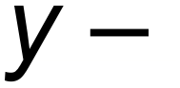axis as shown below.
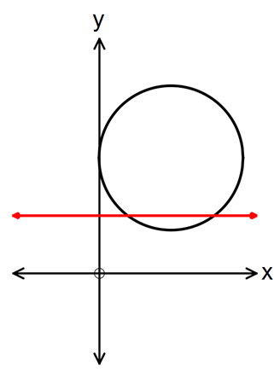
The line y = 4 intersects the circle at point M and N.
[a] Determine the length of the chord MN.

(x – 5)² + (y – 8)² = 25 substitute y = 4 x = 2, x=8 6 units
[b] Find the area of the minor segment formed between MN and the circle.

6² = 5² + 5² – 2 x 5² x cosθ θ = 1.287 radians
$\frac{1}{2}$ x 5² x 1.287 – $\frac{1}{2}$ x 5² x sin(1.287) = 4.0875 units²

The diagram below has an arc, PQ, of a circle with centre O and radius r.
PR is perpendicluar to OQ. Angle POQ = 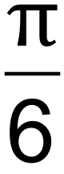 radians.
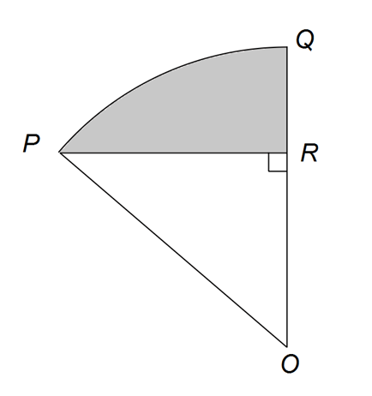
[a] Show that the area of triangle POR = $\frac{r^{2}\sqrt{3}}{2}$ in terms of r. (Hint: First find expressions for OR and RR in terms of r).

sin($\frac{π}{6}$) = $\frac{PR}{r}$ PR = $\frac{r}{2}$
cos($\frac{π}{6}$) = $\frac{OR}{r}$ OR = $\frac{r\sqrt{3}}{2}$
Triangle area = $\frac{1}{2}$ x $\frac{r\sqrt{3}}{2}$ x $\frac{r}{2}$ = $\frac{r^{2}\sqrt{3}}{8}$

[b] If the shaded area is $\frac{2π-3\sqrt{3}}{6}$ cm², calculate the value of r.

Shaded area = sector area – triangle area
$\frac{2π-3\sqrt{3}}{6}$ = $\frac{1}{2}$ x r² x $\frac{π}{6}$ – $\frac{r^{2}\sqrt{3}}{8}$
CAS r = 2, r = –2 (reject x = –2)
r = 2

A sector OPQ of a circle with centre O is drawn below. The radius of the circle is 18 cm and angle POQ is 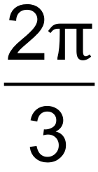 radians. The tangents to the circle at the points P and Q meet at point R. 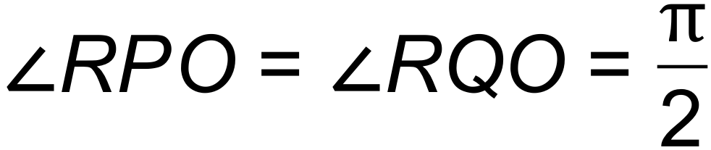. Find the exact area of the shaded region.
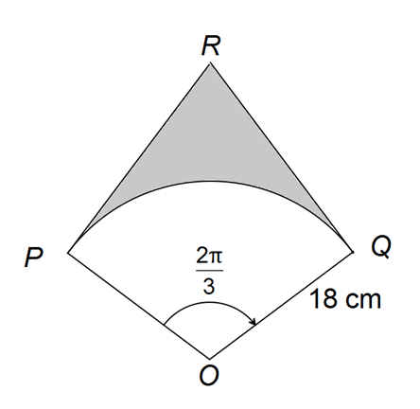
tan($\frac{π}{3}$) = $\frac{PR}{18}$ PR = 18tan($\frac{π}{3}$)
Triangle area = $\frac{1}{2}$bh = $\frac{1}{2}$ x 18 x 18tan($\frac{π}{3}$)
Kite area = 2 x $\frac{1}{2}$ x 18 x 18tan($\frac{π}{3}$) = 18 x 18tan($\frac{π}{3}$)
Sector area = $\frac{1}{2}$ x 18² x $\frac{2π}{3}$
Shaded area = (18 x 18tan($\frac{π}{3}$)) – ($\frac{1}{2}$ x 18² x $\frac{2π}{3}$) = 324$\sqrt{3}$ – 108π = 108(3$\sqrt{3}$ – π)

The graph of y = f(x) is shown below, where f(x) = is shown below, where f(x) = sin(x+c) and c is a constant.
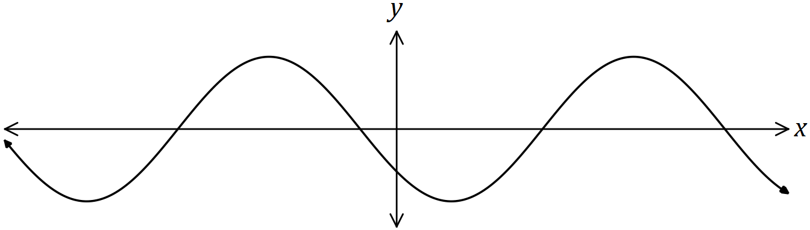
Explain how to obtain the graph of each function below from the graph of f(x), given that a and b are also constants.
[a] y = sin(x+a).
sin(x+c) sin(x+a) Subtract c and add a.
sin(x+c–c+a) = sin(x+a)
sin(x+c–(x–a) = sin(x+a)
Translate horizontally by (c–a) units.

[b] y = cos(x+b).
sin(x+c) cos(x+b)
sin(x+c) = cos(x+c$-\frac{π}{2}$) Subtract c and add b
cos(x+c+$\frac{π}{2}$ – c+b) = cos(x+b)
cos(x+c–($-\frac{π}{2}$+c–b) = cos(x+b)
Translate horizontally by (c–b$-\frac{π}{2}$) units

Complete the square to find the roots of the quadratic function f(x) = 5x² – 7x + 1.
5x²–7x + 1 = 5(x² – $\frac{7}{5}$x + $\frac{1}{5}$)
= 5(x² – $\frac{7}{5}$x + $\frac{49}{100}$ – $\frac{49}{100}$ + $\frac{1}{5}$)
= 5(x – $\frac{7}{10}$)² – $\frac{29}{20}$
5(x – $\frac{7}{10}$)² = $\frac{29}{20}$
(x – $\frac{7}{10}$)² = $\frac{29}{20}$ x $\frac{1}{5}$ = $\frac{29}{100}$
x – $\frac{7}{10}$ = $\sqrt{\frac{29}{100}}$ = ±$\frac{\sqrt{29}}{10}$
x = $\frac{7}{10}$ ± $\frac{\sqrt{29}}{10}$ = $\frac{7±\sqrt{29} }{10}$

